Supplementary material

Supplementary Fig. 1. Box plots exhibiting the mean expression of LINC01234 in cancer and normal tissues in several cancers. The cancer full name on the diagram from top to bottom is shown in the Supplementary Table 1 below.

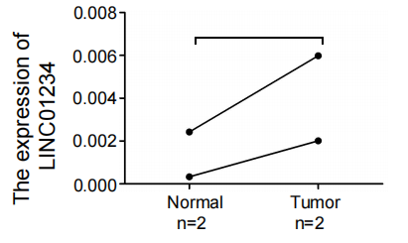
Supplementary Fig. 2. The expression of LINC01234 in 2 paired UCEC tissues and adjacent tissues from patients.

Supplementary Fig. 3. LINC01234 expression influenced the prognosis of UCEC. DFS (disease-free survival) was a prognostic index, and Cox regression analysis indicated that the high expression of LINC01234 was associated with a shorter survival (p < 0.05).

Supplementary Table 1. Full name of the several cancers abbreviation.
rank | 1 | 2 | 3 | 4 | 5 | 6 | 7 | 8 | 9 | 10 | 11
Cancer Name | ACC | BLCA | BRCA | CESC | CHOL | COAD | DLBC | ESCA | GBM | HNSC | KICH
Full Name | Adrenocortical carcinoma | Bladder Urothelial Carcinoma | Breast invasive carcinoma | Cervical squamous cell carcinoma and endocervical adenocarcinoma | Cholangio carcinoma | Colon adenocarcinoma | Lymphoid Neoplasm Diffuse Large B-cell Lymphoma | Esophageal carcinoma | Glioblastoma multiforme | Head and Neck squamous cell carcinoma | Kidney Chromophobe
rank | 12 | 13 | 14 | 15 | 16 | 17 | 18 | 19 | 20 | 21 | 22
Cancer Name | KIRC | KIRP | LAML | LGG | LIHC | LUAD | LUSC | MESO | OV | PAAD | PCPG
Full Name | Kidney renal clear cell carcinoma | Kidney renal papillary cell carcinoma | Acute Myeloid Leukemia | Brain Lower Grade Glioma | Liver hepatocellular carcinoma | Lung adenocarcinoma | Lung squamous cell carcinoma | Mesothelioma | Ovarian serous cystadenocarcinoma | Pancreatic adenocarcinoma | Pheochromocytoma and Paraganglioma
rank | 23 | 24 | 25 | 26 | 27 | 28 | 29 | 30 | 31 | 32 | 33
Cancer Name | PRAD | READ | SARC | SKCM | STAD | TGCT | THCA | THYM | UCEC | UCS | UVM
Full Name | Prostate adenocarcinoma | Rectum adenocarcinoma | Sarcoma | Skin Cutaneous Melanoma | Stomach adenocarcinoma | Testicular Germ Cell Tumors | Thyroid carcinoma | Thymoma | Uterine Corpus Endometrial Carcinoma | Uterine Carcinosarcoma | Uveal Melanoma

